Unleashing Human Potential for Performance and Profit
By
Richard Barrett

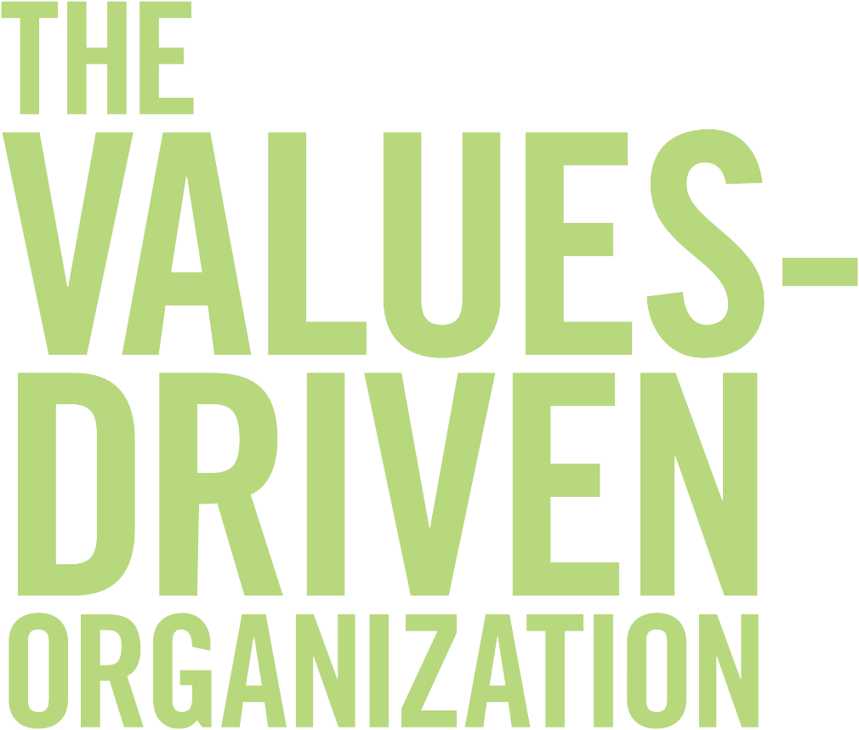

Values-driven organisations are the most successful organisations on the planet.
Values-driven organisations have high levels of employee engagement; they generate higher earnings; they are more profitable, more customer-focused, and more productive—they have high retention rates and low absenteeism. They also generate more customer loyalty and more societal goodwill.
The purpose of this paper is to explain why this is true, and to give some indications as to what is necessary to create a values-driven organisation. For more information on this topic read The Values-Driven Organisation: Unleashing Human Potential for Performance and Profit.

What Does Values-Driven Mean?
In order to understand why values-driven organisations are so successful, we must first understand what being “values-driven” means and how it works in practice. To do that, we need to know what values are and where they come from.
According to sociologists “values” are:
The ideals and customs of a society toward which the people have an effective regard.
I prefer to define values in a more pragmatic way:
Values are a shorthand method of describing what is important to us individually or collectively (as an organisation, community or nation) at any given moment in time.
They are “shorthand” because the concepts that values represent can usually be captured in one word or a short phrase. For example, honesty, openness, compassion, long-term perspective and human rights can all be considered as values. Values are universal: they transcend contexts. Behaviours, on the other hand, are usually described in a “longhand” manner and are context dependent. For example, the behaviours associated with honesty, depending on the context, could be: a) always tells the truth, b) never tell a lie, or c) freedom from deceit or fraud.
What I am also suggesting is that because our values represent what is important to us at any given moment in time, our values are not fixed. The values that are important to you at this particular moment in your life are a reflection of the needs you are experiencing right now, under your current life conditions. An example of how value priorities change with age is shown in Figure 1, which plots the proportion of people in different age groups living in the UK who selected honesty as one of their top ten personal values. You can see from this chart that honesty takes on increasing importance as people get older, but becomes slightly less of a priority for seniors. This does not mean necessarily that seniors are less honest than middle-aged people; it simply means that seniors have more pressing needs which may cause honesty to move to a lower priority ranking.
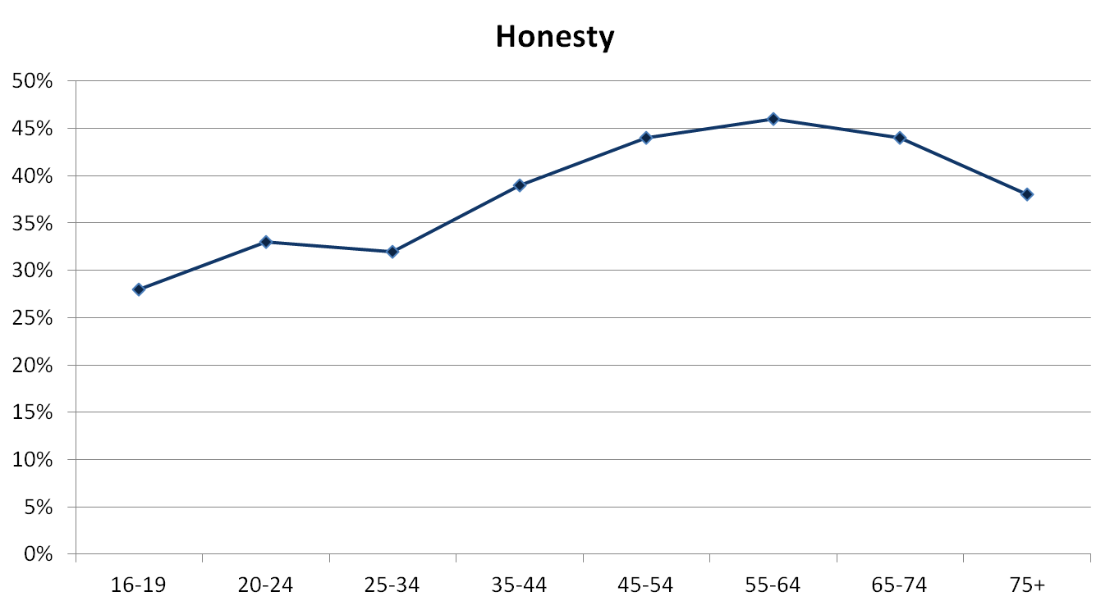
Figure 1: Proportion of people in different age groups in the UK selecting honesty as one of their top ten personal values.
Not all our values change as we grow older. There are some values that we may hold dear throughout our lives. For example, some people will always have honesty as one of their core values. Others, as Figure 1 suggests, give more importance to honesty once they reach their thirties. They begin to recognize honesty is an important component of integrity, and integrity brings many benefits; not the least of which is that it is significant enabler of trust. Consequently, honesty moves up people’s value priority ranking because it becomes more important to meeting their needs.

What are Needs?
A need is something you want to get, have or experience that you believe will make you happier or more aligned with who you are. Consequently, your values are always a reflection of what you consider to be your needs.
There are three levels of needs:
Level of Need | Description
Something you don’t have that you feel you absolutely need. | Something you consider important, that if you had you would feel less anxious or fearful.
Something you don’t have enough of that you feel you absolutely need. | Something you consider important, that if you had more of you would feel less anxious or fearful.
Something you would like to have but is not important to your immediate needs. | Something that you don’t have, that you believe would make you happier or improve your life in some way at some point in time in the future.
Table 1: Three levels of needs
You can see from Table 1 that there are two principal reasons for wanting to satisfy your needs, a) to feel less anxious or fearful, or b) to feel happier or more content.
One of the first researchers to make the link between needs, values and motivations was Abraham Maslow. Maslow (1908-1970), who was a philosopher and one of the foremost spokespersons for humanistic and positive psychology, identified two basic types of human needs:
- Basic needs—also known as “Deficiency” needs.
- Growth needs—also known as “Being” needs.
You feel anxious and fearful when you are unable to satisfy your basic needs, but once they are met, you no longer pay attention to them. When you are able to satisfy you growth needs, they do not go away, they engender deeper levels of attention and commitment. You want more of the feeling that you get when you are able to satisfy these needs.
Maslow describes the relationship between our basic needs and growth needs in the following way:
Man’s higher nature rests on his lower nature, needing it as a foundation… The best way to develop this higher nature is to fulfil and gratify the lower nature first.
Table 2 identifies three types of basic needs (survival, relationship, and self-esteem) and four types of growth needs (transformation, internal cohesion, making a difference and service). The basic needs appear at the bottom of the table and the growth needs appear at the top of the table. The three basic needs and four growth needs represent stages in our psychological development. If we are not able to satisfy our needs at a particular stage of development, we stay at that stage until we can either meet those needs or overcome the fears that are preventing us from satisfying those needs.
For example, you may be in a high-paying job that you find unsatisfying. What you would like to do is follow your passion in a low paying job which is more meaningful to you. Taking a significant cut in income may bring up survival fears. If you allow these fears to dictate your actions, you will not be able to move to the next stage of your development—satisfying your need to find work that is meaningful to you.
Types of Needs | Development Levels | Need Requirements
GROWTH NEEDS  (Being Needs) | Service | Satisfying your need to leave a legacy—to have led a life of significance that will be remembered.
 | Making a Difference | Satisfying your need to actualize your purpose by influencing or impacting the world around you.
 | Internal Cohesion | Satisfying your need for authenticity and to find meaning and purpose for your life.
 | Transformation | Satisfying your need for autonomy, freedom and independence.
BASIC NEEDS  (Deficiency Needs) | Self-esteem | Satisfying your emotional need to be recognized by others as valuable or important because of your skills, talents or qualities.
 | Relationship | Satisfying your emotional need for belonging, protection and connection.
 | Survival | Satisfying your physiological needs for security—staying alive and keeping your body healthy.
Table 2: Basic needs and growth needs
Thus, your potential for happiness, joy and contentment depends significantly on the degree to which the environments in which you live and work are able to satisfy your deficiency needs and nurture/support you in meeting your growth needs.
These findings have significant implications for organisations. If you want to have a loyal, committed and creative workforce then you need to make sure that your employees are able to satisfy their deficiency needs, and you also need to provide programmes and opportunities for them to pursue and satisfy their growth needs. You need to support the psychological development of your employees by implementing structures, policies, systems and procedures that enable them to take care of their families, form friendships with people with whom they work, excel at what they do best, nurture and cultivate autonomy, find authenticity, meaning and purpose, have opportunities to make a difference, and, if possible, leave a positive legacy.
This is what it means to become a values-driven organisation. Values-driven organisations live the values that align with the needs that employees have at every level of their psychological development. When this happens organisations experience a high level of employee engagement. Employees feel engaged because the organisation enables them to meet their needs.

Employee Engagement and Performance
Gallup, a research-based performance-management consultancy, has found that organisations with highly engaged employees have 3.9 times the earnings per share growth rate compared to organisations with low engagement in the same industry. Engaged workgroups are more productive, profitable, and customer focused, and have higher retention rates, lower numbers of safety incidents and less absenteeism than disengaged workgroups.
Gallup concludes from their research that:
In the best organizations, engagement is more than a human resources initiative—it is a strategic foundation for the way they do business. Increasing employee engagement correlates directly with a positive impact on key business metrics. The best-performing companies know that an employee engagement improvement strategy linked to the achievement of corporate goals will help them win in the marketplace.
Another global Human Resource Consulting firm, AON Hewitt, found that companies with high levels of engagement (65% or greater) outperform the stock market, posting total shareholder returns 22 percent more than the average. Companies with low engagement (45% or less) had total shareholder returns that were 28 percent lower than average. Furthermore, AON Hewitt estimates that a disengaged employee costs an organisation an average of $10,000 in profit annually; as a result organisations with high engagement are 78% more productive and 40% more profitable. Aon Hewitt also found that in the most recent economic downturn (2008), organisations with high engagement scores were more resilient than companies with low engagement scores.
Research carried out by the UK retail giant, Marks and Spencer, shows that over a four year period stores with improving engagement delivered £62 million more in sales to the business every year than stores with declining engagement. Research carried out at Sainsbury’s, another UK retail giant, found a clear link between sales performance and higher levels of engagement: high levels of engagement contributed up to 15% of a store’s year on year growth. RSA, a global insurance company, discovered from their research that call centres with higher levels of employee engagement had 35% less downtime between calls.
In their 2012 report, the UK Employee Engagement Task Force identified four enablers of employee engagement:

- Visible, empowering leadership providing a strong strategic narrative about the organisation, where it’s come from and where it’s going.
- Engaging managers who provide focus for their people and give them responsibility, treat their people as individuals, and coach, support and stretch their people.
- Giving employees a voice to either reinforce or challenge existing views.
- Organisational integrity—the values on the wall are reflected in day-to-day behaviours. There is no “say-do” gap.
In the UK, data provided to the Task Force by Towers Watson showed that only twenty-seven percent of employees in the are “highly engaged”. This huge engagement deficit has a significant impact on UK productivity figures—output per hour in the UK was fifteen points below the average for the rest of the G7 industrialized nations in 2011. On an output per worker basis, UK productivity was twenty points lower than the rest of the G7.

The Task Force’s report concludes:
Releasing the potential of an engaged workforce holds the prospect of reducing costs associated with sickness, absence, employee turnover, production errors, accidents and inefficient processes. It also holds the prospect of improving productivity, customer satisfaction, customer retention and innovation. Any one of these mechanisms is capable of delivering substantial benefits to the bottom-line performance of organisations. The question of how to proceed remains unanswered, as this will depend on the specific circumstances of individual organisations, but the evidence in this report suggests that the best place to look for answers is with your employees.

Employee Centricity
Having established that there are strong links between employee engagement and performance, let us now turn our attention more specifically to the financial returns that can be generated by a highly engaged workforce by referencing Fortune Magazine’s “100 Best Companies to Work For.” This survey, which recognises the best companies to work for in America, is conducted by the Great Place to Work institute.
In the survey, two thirds of each company’s final score is based on the responses to the Institute’s Trust Index survey, which is sent to a random sample of employees. The survey asks questions related to attitudes about management's credibility, job satisfaction, and the general level of camaraderie that exists in the organisation. The other third of the score is based on the company's responses to the Institute's Culture Audit, which includes detailed questions about pay and benefit programs, and a series of open-ended questions about hiring practices, internal communication, training, recognition programs, and diversity efforts.
In order to evaluate the financial performance of the best companies to work for (in America), I measured the growth in share price of the top forty publicly traded, best companies to work for over the period July 2002 to July 2012 and compared the result with the growth in share price of the S&P 500 over the same period. The results are shown in Figure 2.
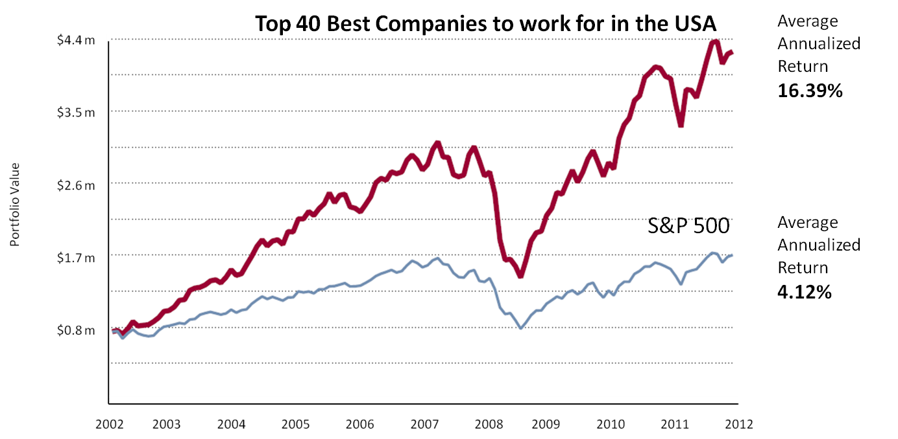
Figure 2: Growth in share price of the top forty publicly traded best companies to work for in America, July 2002-2012 compared to the S&P 500.
An investment of $25,000 in each of the top forty companies to work for (total investment of $1 million) over this 10-year period would have realized an average annualized return of 16.39 percent, compared to 4.12 percent for the S&P 500. Not only did the stocks of the top companies to work for significantly outperform the S&P 500 over this ten-year period, they also showed considerably more resilience in regaining their value after the global economic meltdown of 2008. They regained their pre-meltdown value in just over a year whereas it took three years for the S&P 500 companies to regain their value. I believe that the strong financial performance of these “people focused” companies underlines the importance of the employee experience to the success of a company.
It is clear from the reports, studies and research cited above that caring about the needs of employees (their basic needs and growth needs) is significantly correlated with financial success. We have also found in our own research at the Barrett Values Centre that employee engagement is also strongly correlated with cultural entropy.
Cultural entropy is a measure of the amount of energy that is consumed in doing unnecessary or unproductive work—the amount of conflict, friction and frustration that employees encounter in their day-to-day activities that prevent them and the organisation from operating at peak performance. The main source of cultural entropy in an organisation is the fear-based actions and behaviours of the leaders, managers and supervisors.
When leaders, managers and supervisors are anxious and fearful (when they have unmet deficiency needs and engage in dysfunctional behaviours such as control, manipulation, blame, internal competition, etc.) cultural entropy increases and employee engagement decreases. Conversely, when leaders, managers and supervisors engage in caring and trusting behaviours and the organisation encourages its employees to be responsible and accountable for their work, allowing them free rein to take initiatives which boost performance, cultural entropy decreases and staff engagement increases.
Figure 3 shows the relationship between cultural entropy and employee engagement as measured in 163 organisations in Australia and New Zealand in a joint research project carried out by Barrett Values Centre and Hewitt Associates in June 2008. The results of this analysis show that cultural entropy and employee engagement are highly inversely correlated—companies with low cultural entropy have high employee engagement and companies with high cultural entropy have low employee engagement.

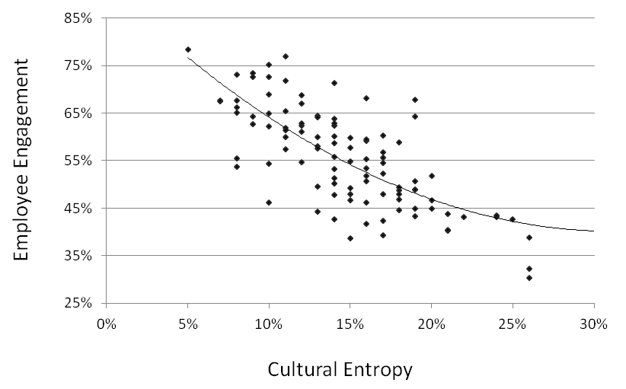
Figure 3: Employee engagement vs. Cultural entropy
In organisations with high cultural entropy (disengaged employees), the leaders, managers and supervisors are focused on addressing their own needs. In organisations with low cultural entropy (engaged employees), the leaders, managers and supervisors are focused on meeting the needs of their direct reports and other colleagues, the needs of customers, the needs of investors and the needs of the people in the communities where they operate. By focusing on the needs of all the organisation’s stakeholders they engender high levels of staff engagement, customer support, investor attention and societal goodwill.

Conclusions
All this research into the cultures of top performing organisations suggests that whilst caring about the needs of employees and other stakeholders is important, it is not sufficient—you must also create a high-trust culture that inspires employees to bring their full selves to work. This means working with the organisation’s leaders, managers and supervisors to reduce their level of personal entropy. Personal entropy is the amount of fear-driven energy that a person expresses in his or her day-to-day interactions with other people—energy which is focused on self-interest rather than the common good.
Humans are basically social creatures: we depend on each other for our individual and collective survival, progress and success. When one person in a group is focused more on his or her own success than the group’s success, then discord and conflict will ensue, and the group will become dysfunctional. With such a culture, the group will never be able to achieve its full potential.
When people, especially leaders, operate with pure self-interest, they not only compromise their own future well-being, they also compromise the well-being of the organisation, group or community they belong to. The collapse of companies such as Enron, Tyco International and WorldCom are a testament to this fact.
Fear-driven energy arises from the conscious and subconscious fear-based beliefs (limiting beliefs) that people have about meeting their deficiency needs.
- Limiting beliefs at the survival level are about not having enough of what you need to feel safe and secure. These beliefs result in the display of potentially limiting values such as control, manipulation, greed, and excessive caution.
- Limiting beliefs at the relationship level are about not feeling loved enough to be accepted and protected. These beliefs result in the display of potentially limiting values such as blame, being liked, competition and internal politics,
- Limiting beliefs at the self-esteem level are about not being enough to engender the respect or acknowledgement of the authority figures in your life or your peers. These beliefs result in the display of potentially limiting values such as status seeking, power-seeking, arrogance and an overly strong focus on self-image.
When you truly get to the heart of the matter—what creates long-lasting value for investors—you cannot fail to come to the conclusion that culture is everything! Culture drives performance by unleashing human potential.
The culture of an organisation is defined by the values that are lived by the leaders, managers and supervisors. These are not necessarily the espoused values—the values that the organisation says it wants to embrace—but the values that exist in reality and show up in the everyday interactions between leaders, managers and employees, and between employees and customers and suppliers.
The conclusion I have reached is that if you want to build a high performing organisation with superior financial returns, then you will need to focus on satisfying the needs of all your stakeholders, especially the needs of your employees—their basic needs and their growth needs.

Richard Barrett, The Values-Driven Organisation: Unleashing Human Potential for Performance and Profit (London: Routledge), August, 2013.
Abraham Maslow, Toward a Psychology of Being (Second Edition) (New York: Van Nostrand Reinhold), 1968, p. 173.
Employee Engagement: What’s Your Engagement Ration, Gallup Consulting (PDF)
Ibid.
Trends in Global Employee Engagement, AON Hewitt, 2011.
Economic uncertainty creates a recession in employee engagement: How top organisations continue to prosper, AON Hewitt, Hewitt Engagement Recession Article HBR.pdf
Bruce Rayton, Employee Engagement Task Force “Nailing the evidence” workgroup (University of Bath School of Management), 2012, pp. iii-iv.
Ibid., p.1.
Ibid., p. 4.
Ibid., p. ii.
Ibid., p. 26.
S&P 500: Standard & Poor's 500, is a stock market index based on the common stock prices of 500 top publicly traded American companies.
For a full description of cultural entropy and how to measure it see http://valuescentre.com.

